**IFT 533: Data Vis & Reporting for IT**

**Project - Phase II: Decision Making**

**Instructor: Asmaa Elbadrawy**

Brain Boosters Teammates:

Sai Sushank Manthri Pramod

Lakshman Sai Yaganti

Tej Thanush Peddineni

**Section 1: Used Visualization Tools**

Tableau represents one of the tools for visualization I used to build the dashboard. Tableau is a feature-rich, user-friendly data visualization application that can be used to create dynamic, informative dashboards. Because of its intuitive interface and simple dragging and dropping capability, it may be used by people with different degrees of technical proficiency. Furthermore, Tableau has strong data connectivity features that let users quickly link to a variety of information sources. This facilitates the easy integration of data from multiple sources onto one dashboard, allowing for comprehensive evaluation.

In addition, Tableau provides a wide range of visualization choices, including as maps, graphs with bars, line graphs, scatter graphs, and more. With the help of these adaptable visualization tools, customers may examine a wide range of trends and patterns within the information and efficiently depict diverse types of information. Report Word In addition, Tableau's interactive features—like filters, variables, and tooltips—improve user interaction and make it easier to go more into data analysis.

**Section 2: Explanation of Required Data Pre-processing, if any**

Several procedures may be done to guarantee that the information is clean and suitable for display to prepare the information and eliminate undesirable symbols like "�".  
Initially, data exploration methods may be used to go through the information to find these symbols. This entails examining the information to look for any irregularities or discrepancies and figuring out which particular letters or symbols should be eliminated. Once detected, manipulation of data techniques like string replacements or filtering can be used to change or delete these characters.

Secondly, cleaning data techniques can be used to address values that are lacking or corrupted, since these could be the reason why undesirable symbols are showing up. This might entail interpolating values that are missing based on nearby data points, assigning values that are missing, or deleting columns or rows with a high percentage of missing data. Unnecessary characters in the data set can be lessened by filling in the missing values.

Lastly, to guarantee uniformity and consistency in the data, standardization and normalizing procedures might be used. This might entail standardizing numerical data formats, eliminating punctuation and particular characters, and converting textual data to lowercase. We can guarantee that the data is in a clear and consistent format that is appropriate for visualizing and analyzing it by standardizing it.

We can efficiently clean and prepare the information for visualization by putting these pretreatment processes into practice. This ensures that undesired symbols, such as "�" are eliminated and the information is prepared for insightful interpretation and analysis.

**Section 3: List of Final Sets of Questions**

1. Which restaurants have the highest number of votes and how does it correlate with their ratings?
2. How does the average cost for two vary by city and cuisine?
3. How do ratings correlate with the price range of restaurants?
4. Which cities have the highest number of restaurants offering online delivery?
5. How does the number of available cuisines affect restaurant popularity in terms of votes?
6. How to find total number of ratings for every restaurant?
7. How to find total number of cuisines based on city?
8. Do restaurants with table booking options tend to have higher ratings?
9. How does online food ordering vary across different Country pin codes?
10. How does the frequency of table bookings correlate with the overall count of restaurants?

**Section 4: List of Plots**

**1. Which restaurants have the highest number of votes and how does it correlate with their ratings?**

Column: Restaurant Name

Row: Votes (Sum)

Each restaurant is displayed by name in this visualization, and the amount of votes each one has gotten is indicated by bars. Each bar's color represents the restaurant's overall rating, demonstrating the relationship between perceived quality and popularity. With this, you may gain an understanding of consumer happiness and restaurant performance by knowing which restaurants are the most popular (as determined by votes) and how this popularity connects to their ratings.

Size: Length of the bar indicates the number of votes.

Color: Gradient color scale representing the rating, with warmer colors indicating higher ratings and cooler colors for lower ratings.

Rough Sketch:

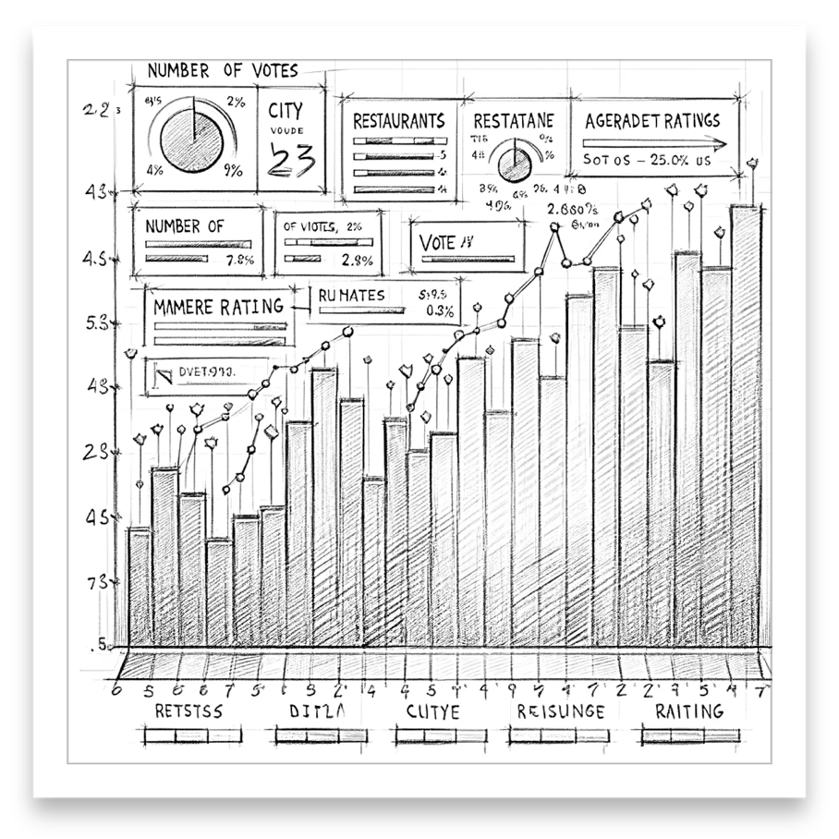

Actual Sketch:

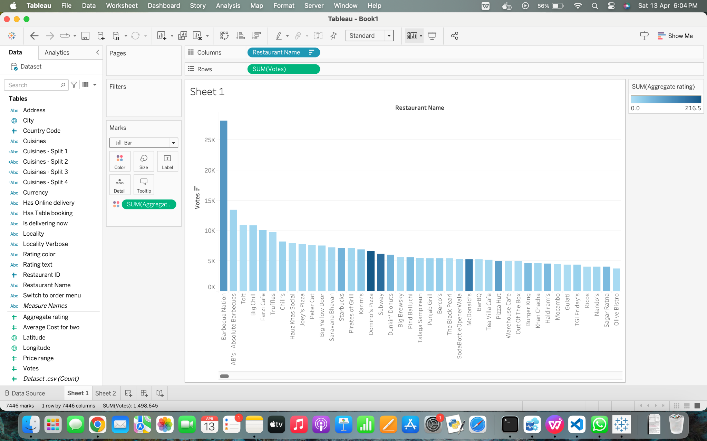

**2. How does the average cost for two vary by city and cuisine?**

Column: City

Row: Average cost for two (Avg)

The average cost of a two-person meal is shown in this image, which is further broken down by cuisine and divided by city. This enables consumers to comprehend not just which cities have higher average costs but also how those costs change based on the sort of cuisine found in those places. Gives a direct answer to the subject of price differences by comparing prices between cities and cuisines.

Size: Length of the bar indicates the average cost.

Colour: Gradient or conditional colouring highlights cost differences, making it easy to spot cheaper and pricier options.

Rough Sketch:

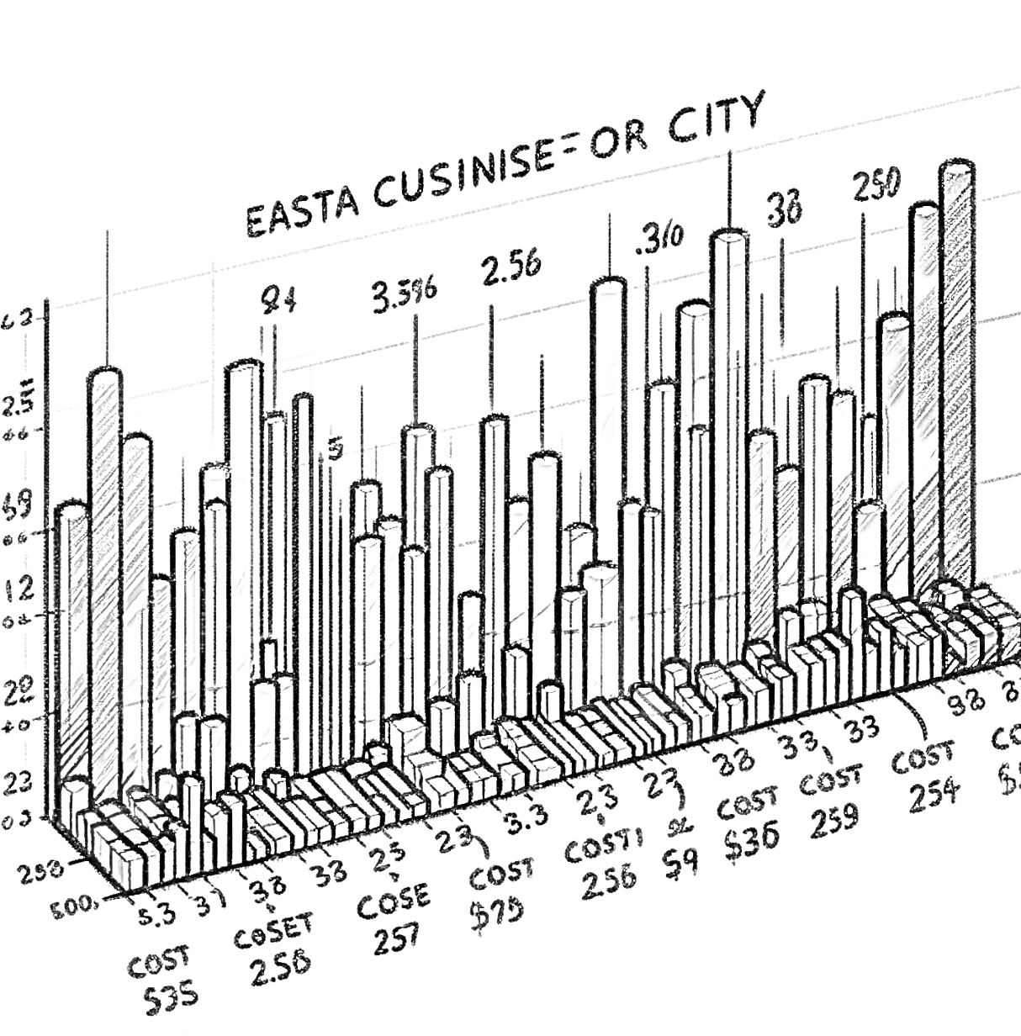

Actual Sketch:

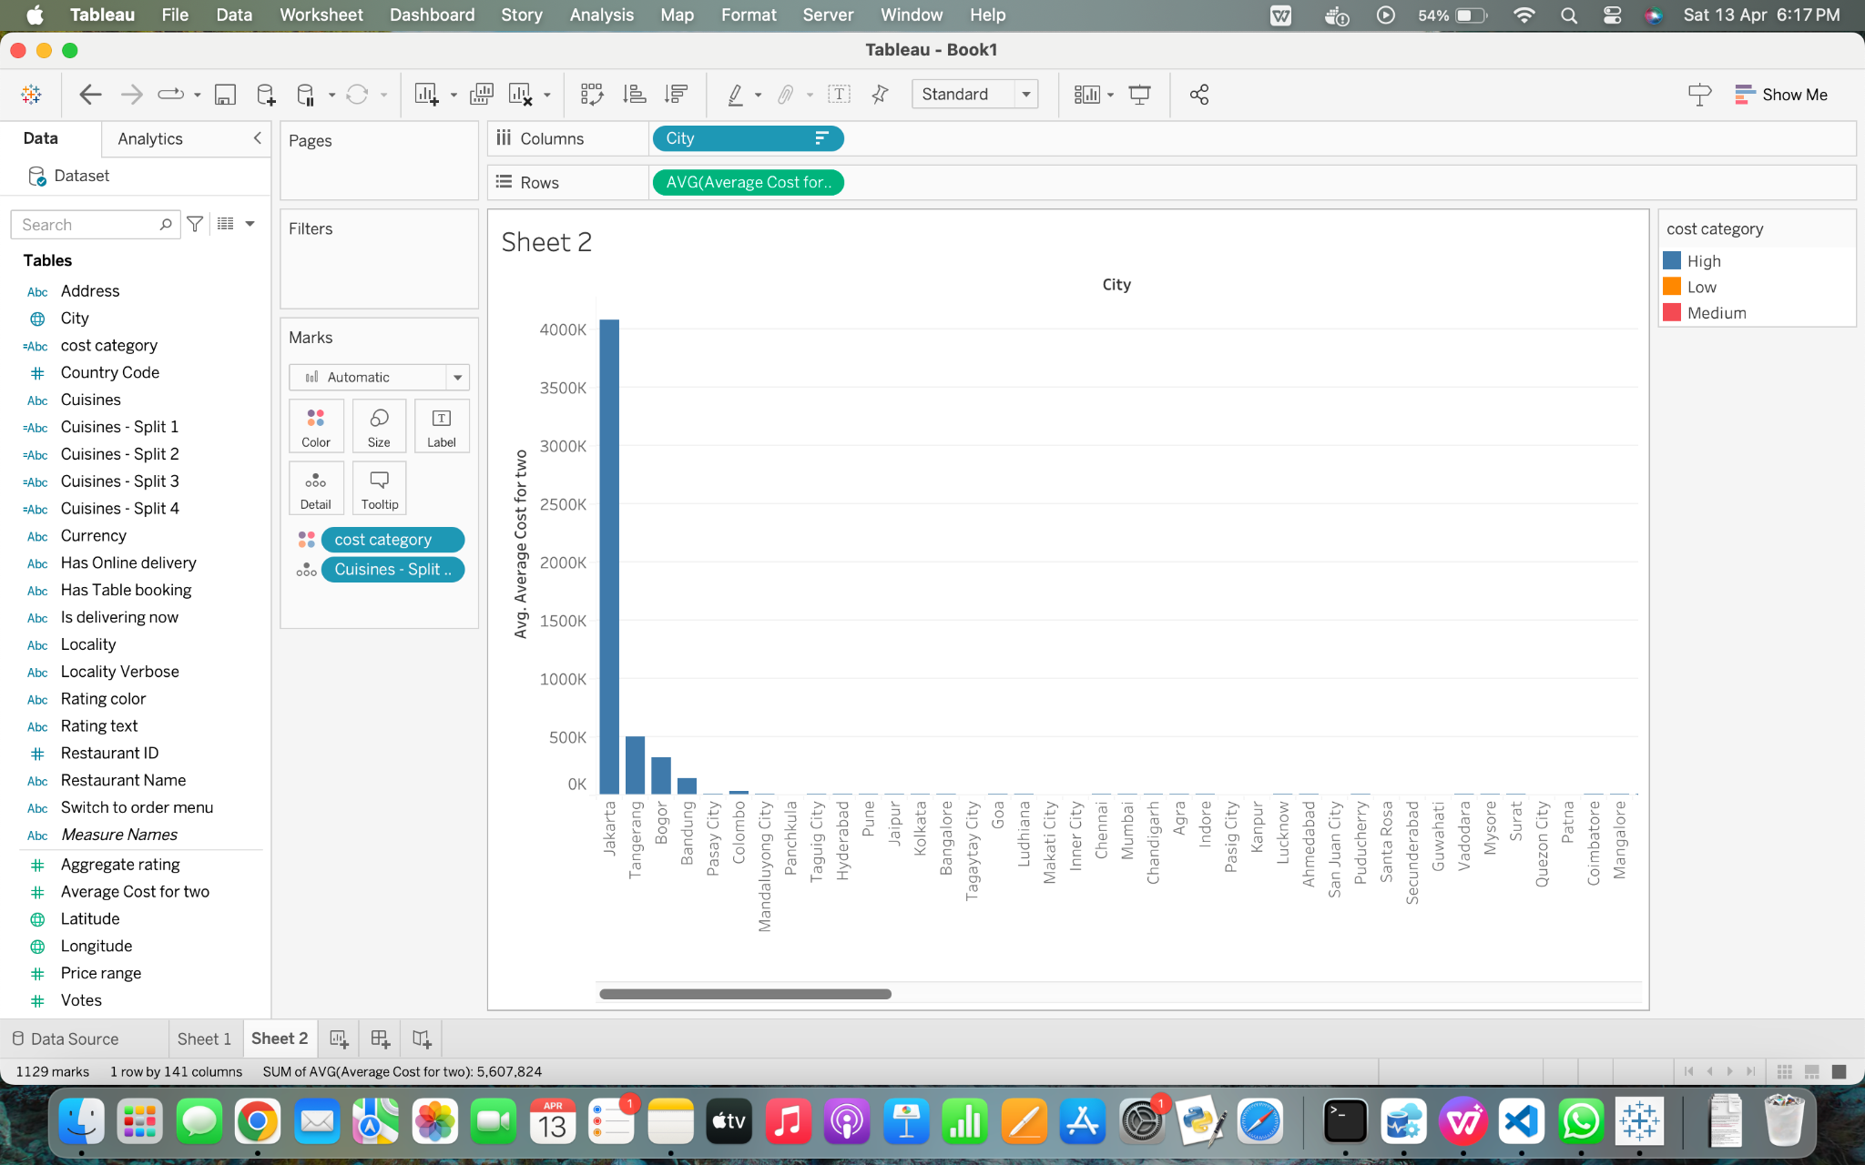

**3. How do ratings correlate with the price range of restaurants?**

Column: Price Range (Sum)

Row: Aggregating Rating (Sum)

This scatter plot illustrates the relationship between restaurant prices and ratings. Plotted based on price range and overall rating, each point represents a restaurant. It provides a clear response to the query of whether higher-priced restaurants typically receive higher evaluations, addressing the link between cost and perceived quality.

Position: Horizontal position indicates price range; vertical position indicates rating.

Colour: Use different colours for each cuisine type or city to see patterns within subgroups.

Size: Points can be sized by the number of votes to show popularity.

Rough Sketch:

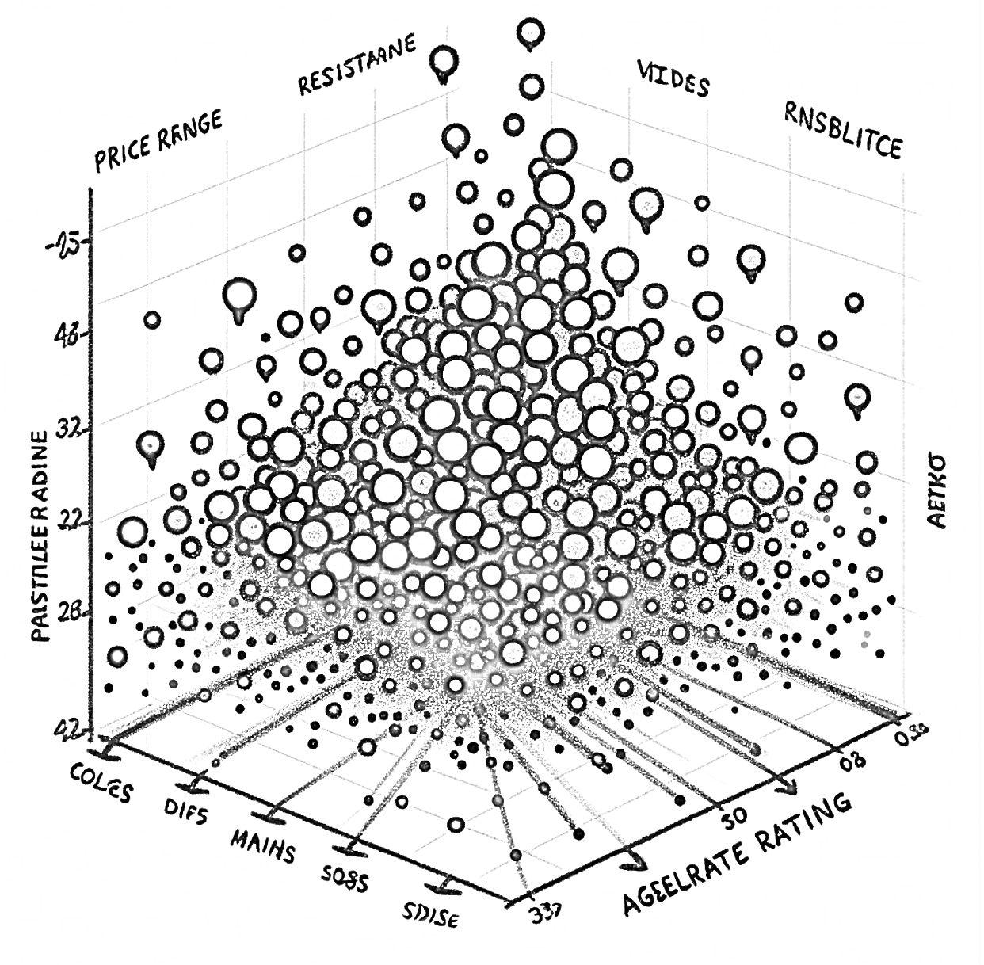

Actual Sketch:

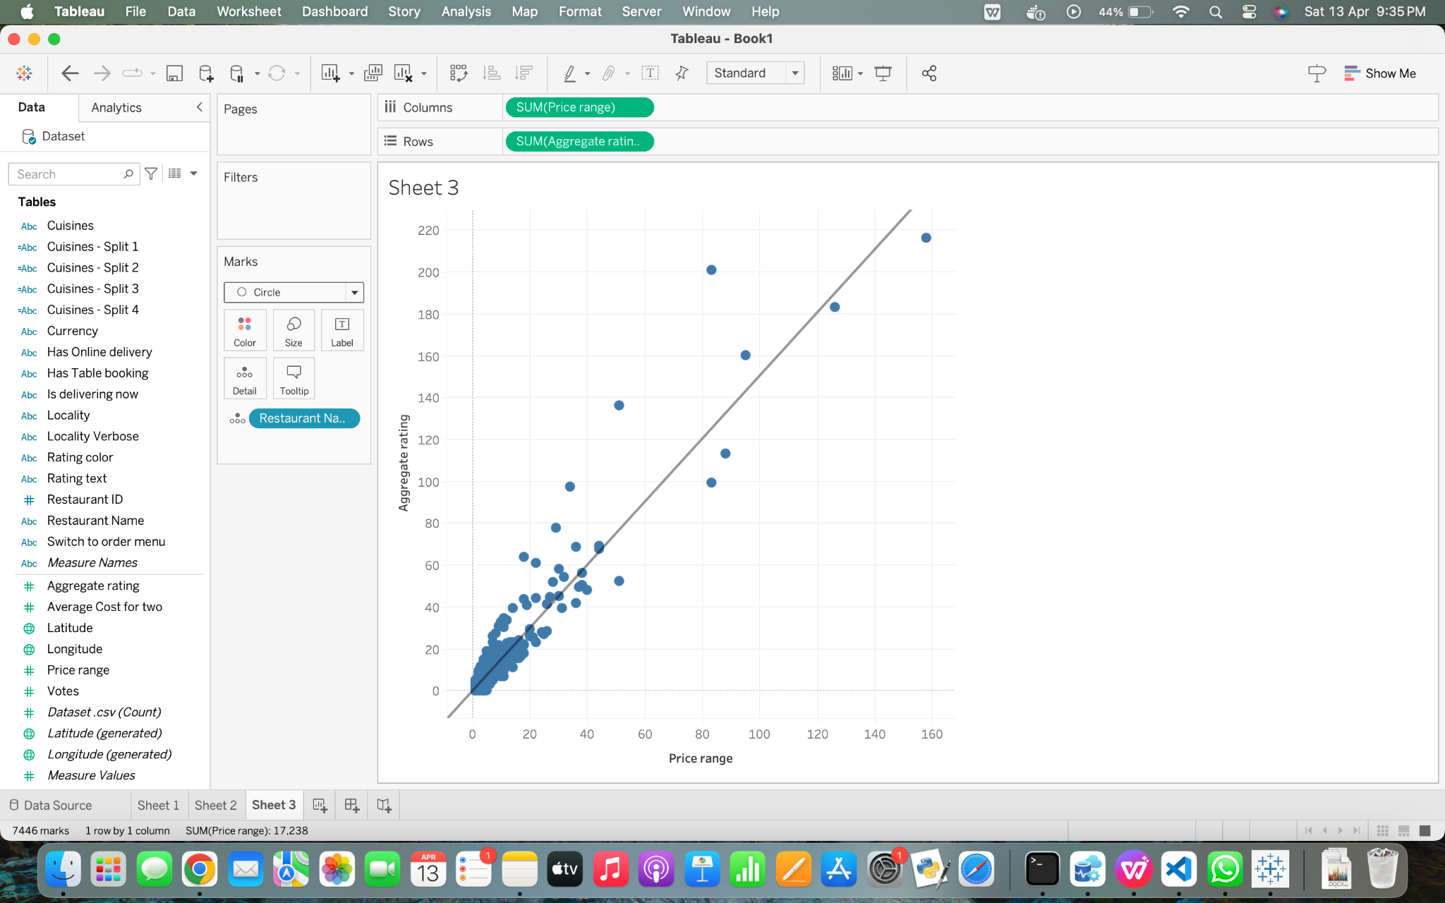

**4. Which cities have the highest number of restaurants offering online delivery?**

The percentage of restaurants that provide online delivery is shown in a pie chart that is broken down by city. Every slice is a city, and the size of the slice shows how many restaurants in that city provide delivery services. Clearly responds to the query of which cities have the greatest concentration of eateries that deliver food online, assisting interested parties in identifying important online service markets.

Colour: Each city is represented by a different colour, making it easy to distinguish between them.

Size: The size of each pie slice visually represents the quantity, quickly highlighting cities with more delivery options.

Rough Sketch:

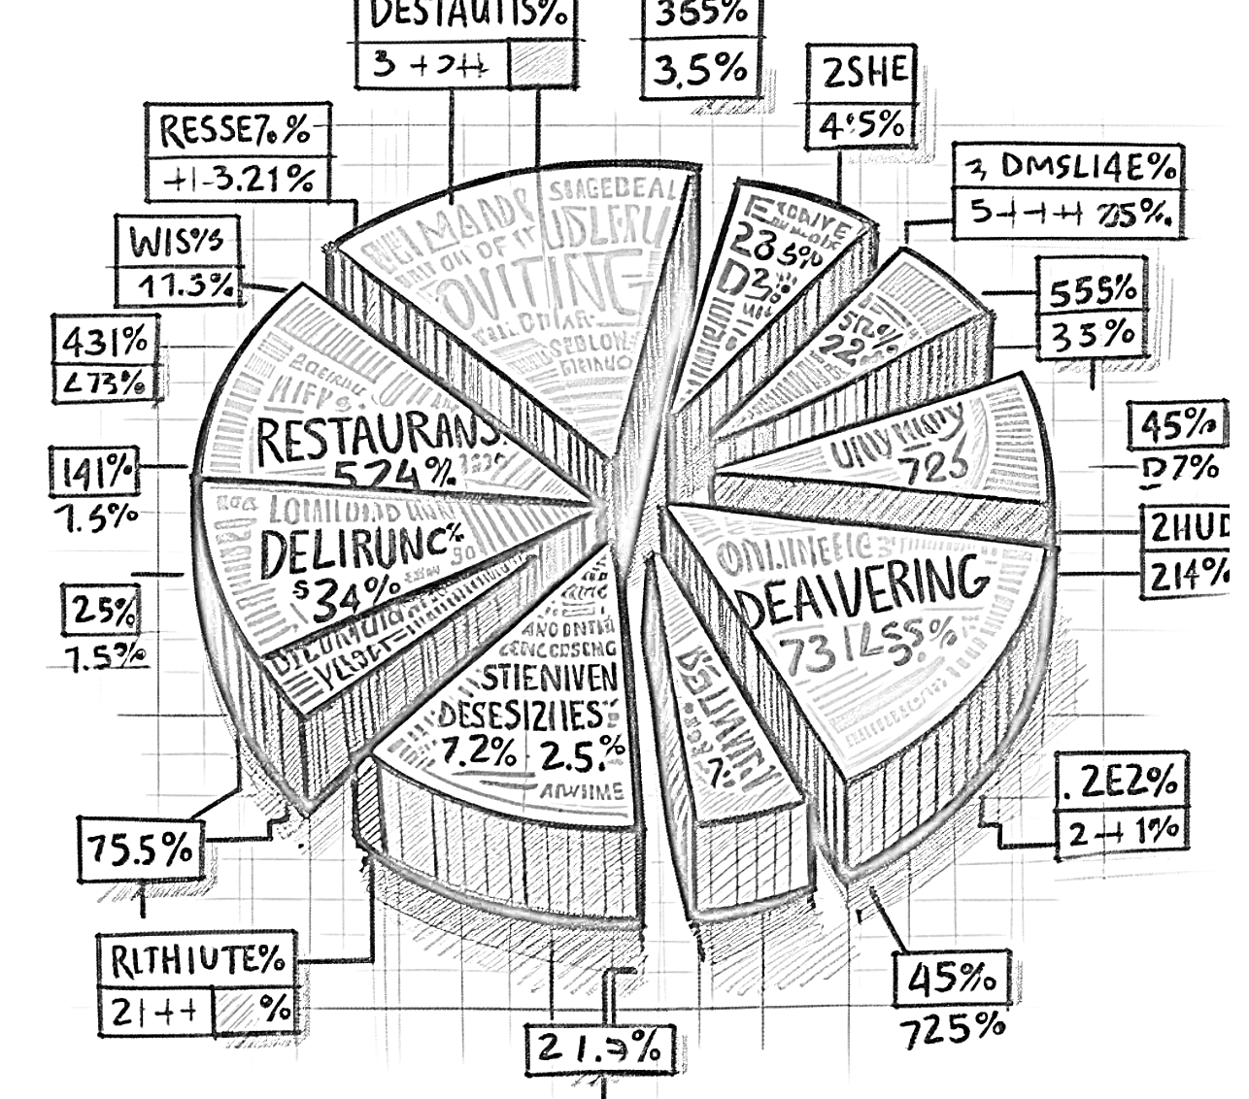

Actual Sketch:

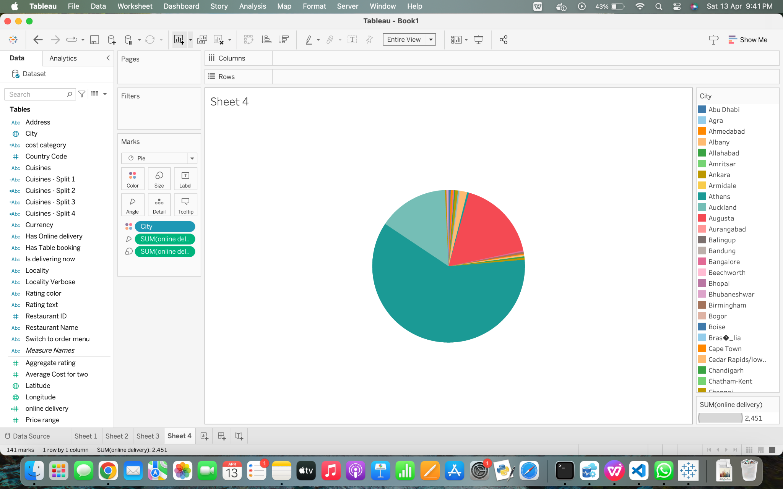

**5. How does the number of available cuisines affect restaurant popularity in terms of votes?**

Column: Number of Cuisines (Sum)

Row: Votes (Sum)

The line graph shows patterns in the relationship between a restaurant's popularity—as measured by the number of votes—and the number of cuisines it offers. The average or total number of votes that restaurant serving that many different cuisines earned is shown by each point on the line. Explains in detail how the popularity of restaurants is affected by the diversity of food.

Colour: Different colours can represent different cities or restaurant groups, making it easy to compare across groups.

Lines: The slope and direction of the lines indicate trends in popularity as the number of cuisines changes.

Rough Sketch:

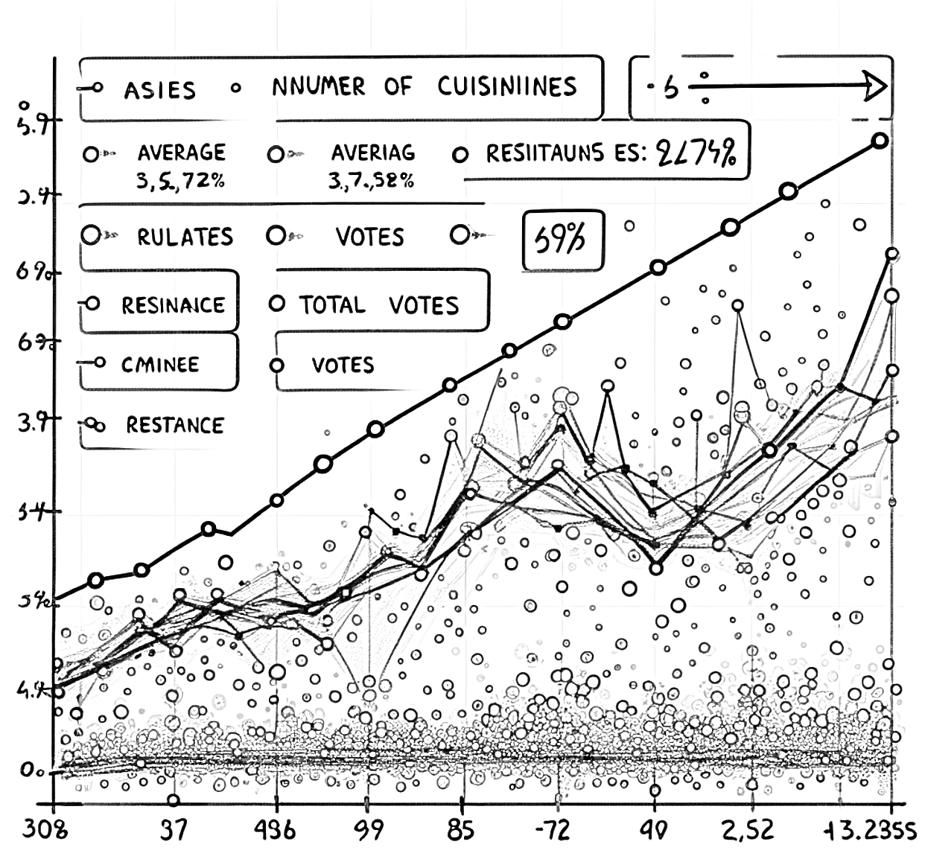

Actual Sketch:

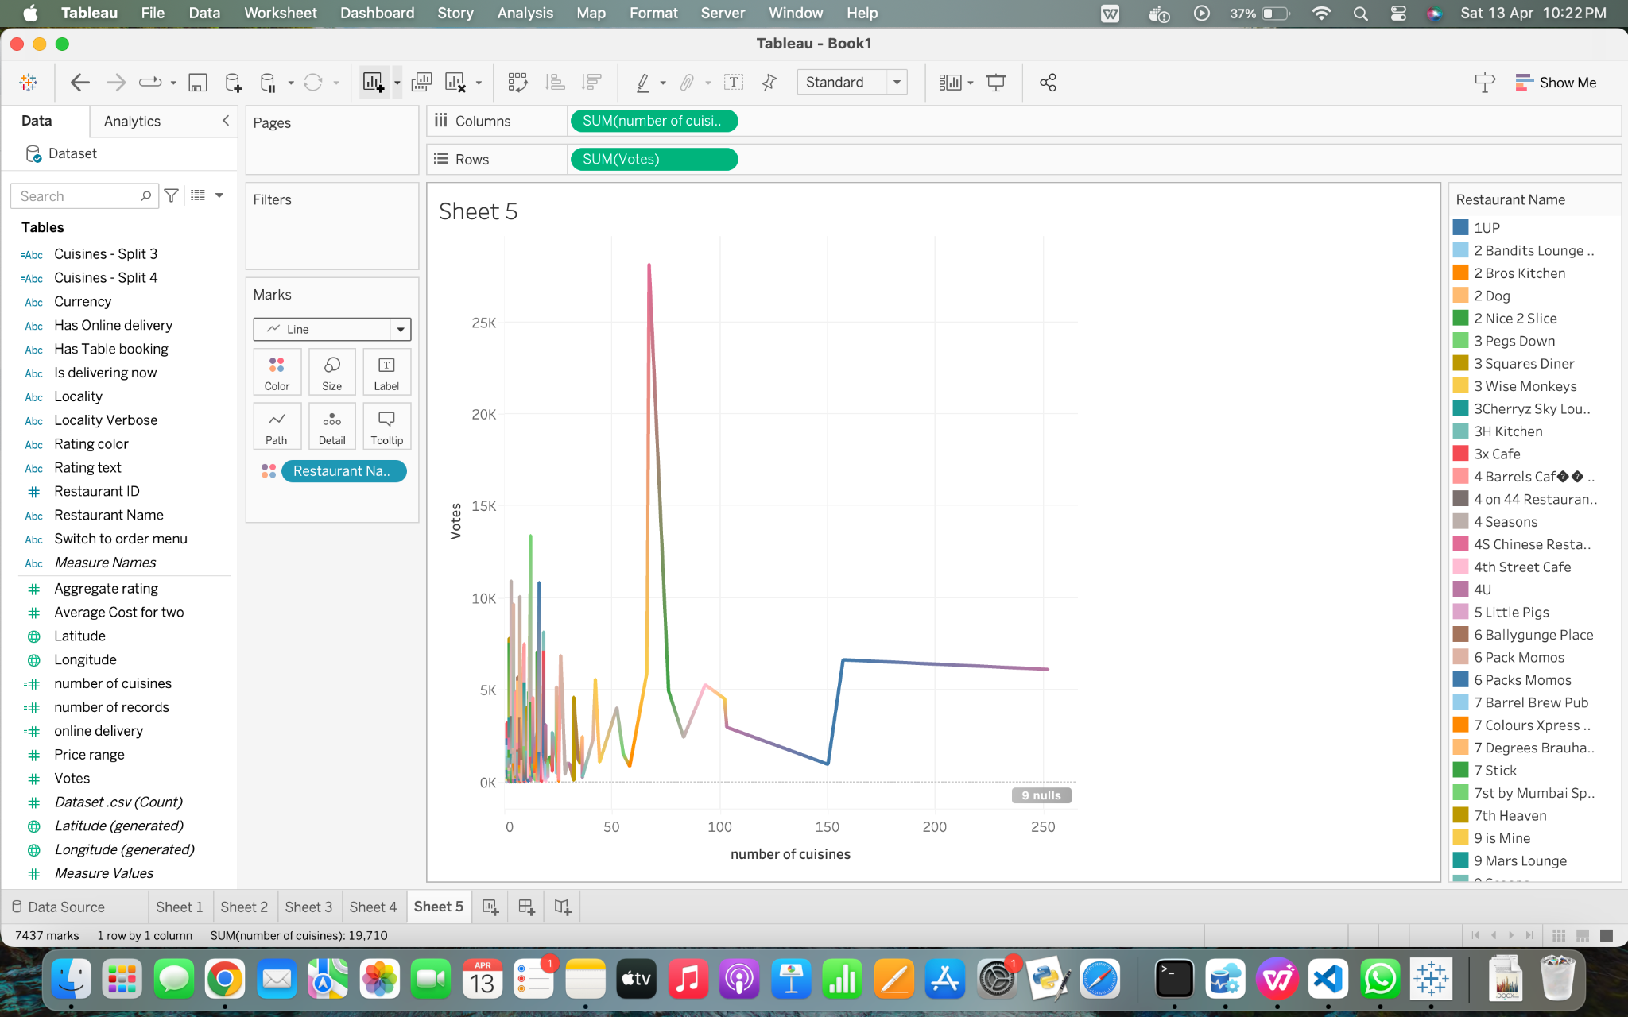

**6. How to find total number of ratings for every restaurant?**

Columns: Rating text

Rows: Count of dataset

Color: Rating text

The total number of ratings for every restaurant in the information set is displayed on the dashboard that you defined. The dashboard shows how often of every rating (such as Excellent, Very Good, Good, etc.) that each restaurant has gotten through the use of the filter "restaurant name." The rating text is used as columns, the dataset counts as rows, and the filter is applied.

Through this visualization, visitors can see how different restaurants are evaluated by patrons and gain insight into how ratings are distributed across them.

This visualization makes use of the following pre-attentive attributes:

Length: The total number of ratings a restaurant has gotten is shown by the total length of each bar.

Location: The number of ratings of each restaurant is shown by the location of each bar on the y-axis.

Color: Each one rating text (Excellent, Very Good, Good, etc.) is denoted by a distinct color.

Rough Sketch:

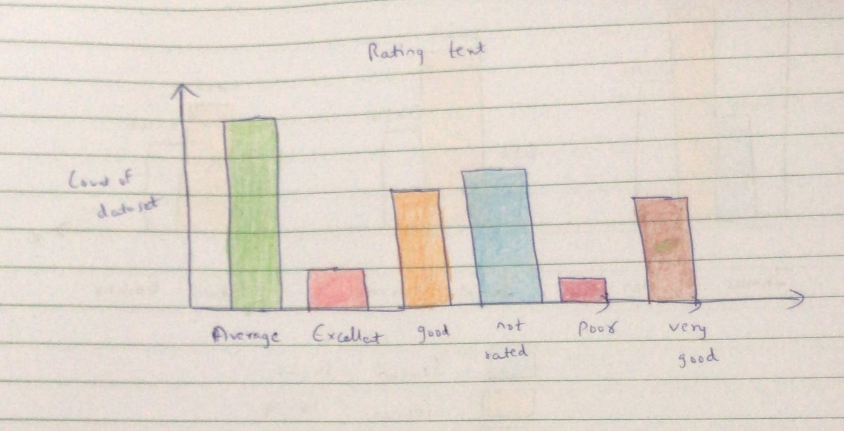

Actual Diagram:

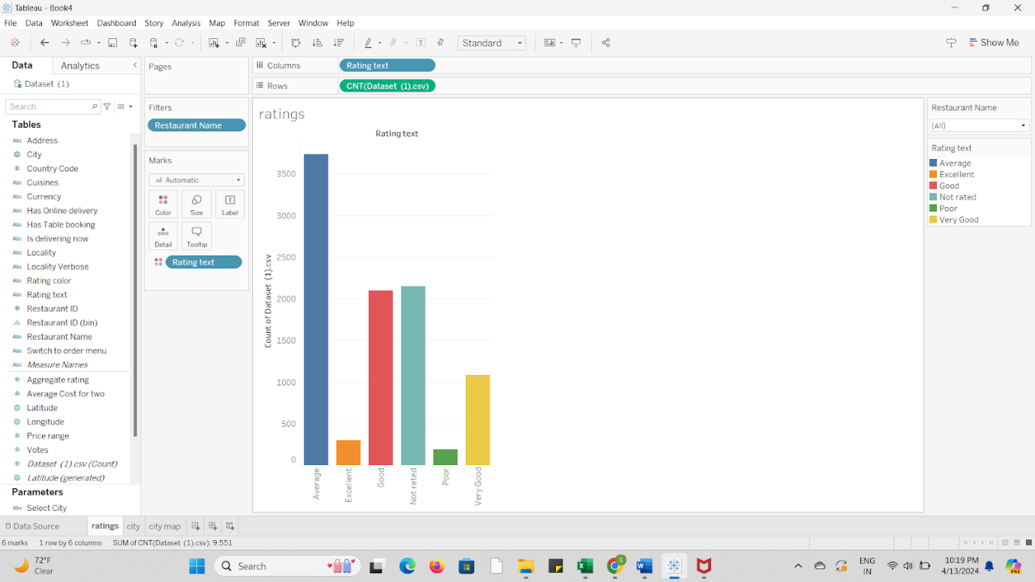

**7.** **How to find total number of cuisines based on city?**

Rows: Count of dataset

Columns: Cuisines

Color: Cuisines

The total amount of cuisines available per city in the information set is displayed in the visualization that is discussed. The dashboard shows how often there is of each cuisine provided in each city by applying a filter that is based on the city, and utilizing cuisine as columns and dataset count as rows.  
Users may see how many various sorts of cuisines are supplied in each city, which gives insight into the variety of cuisines accessible in different cities.   
Used pre-attentive characteristics were:  
Length: The number of cuisines served in each city is represented by the total length of each bar.  
Location: The number of cuisines for every town is shown by the location of each bar on the y-axis.  
Color: Each cuisine can be represented by a distinct color, which makes it simpler to distinguish between them.

Rough Diagram:

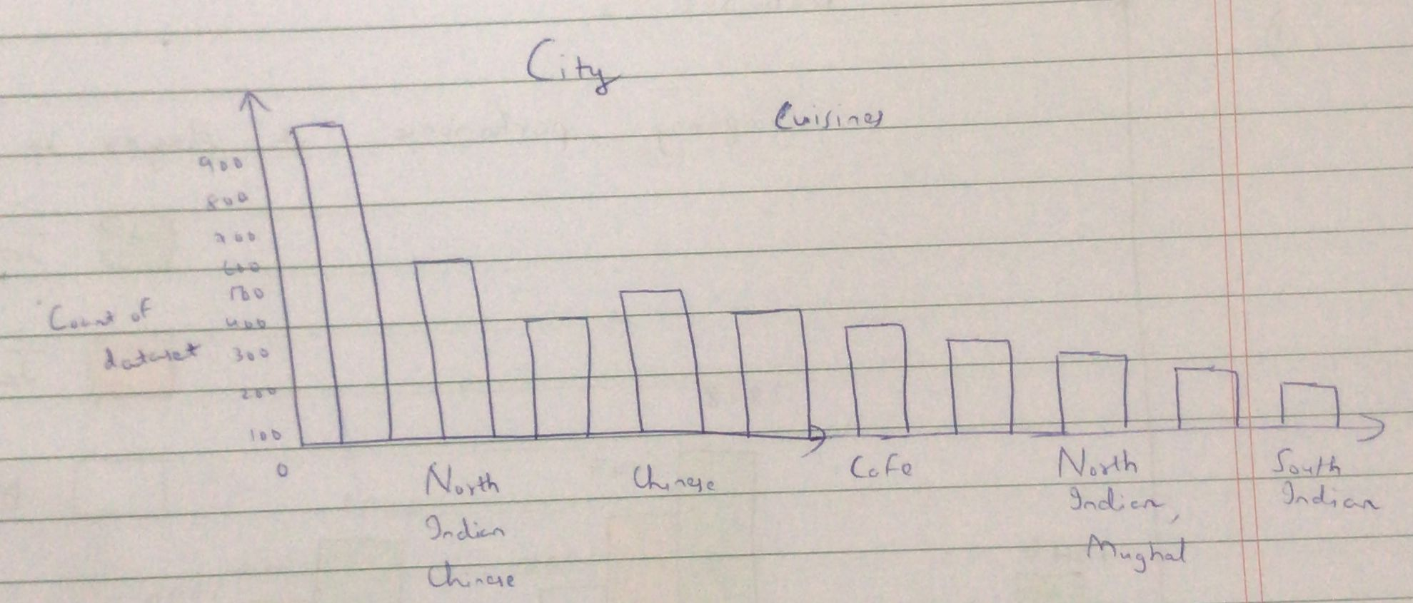

Actual Sketch:

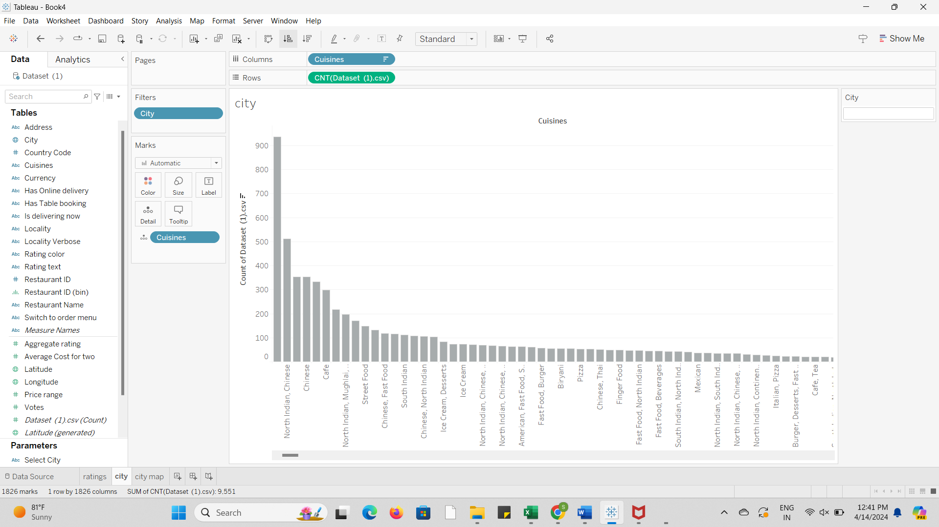

**8. Do restaurants with table booking options tend to have higher ratings?**

Columns: Has Table Booking (Boolean)

Rows: Count of Restaurants

Color: Average Aggregate Rating

Pre-attentive Attributes:

* Length: Use varying lengths for the columns representing restaurants with and without table booking options to show the count of restaurants.
* Color: Use different colors to represent the average aggregate rating, with warmer colors indicating higher ratings and cooler colors for lower ratings.

Explanation: This visualization examines whether restaurants offering table booking options tend to receive higher ratings compared to those without this feature. By displaying the count of restaurants on the Y-axis, with separate columns for restaurants with and without table booking options, and using color to represent the average aggregate rating, we can determine if there's a trend indicating higher ratings for restaurants with table booking.

Rough Sketch:

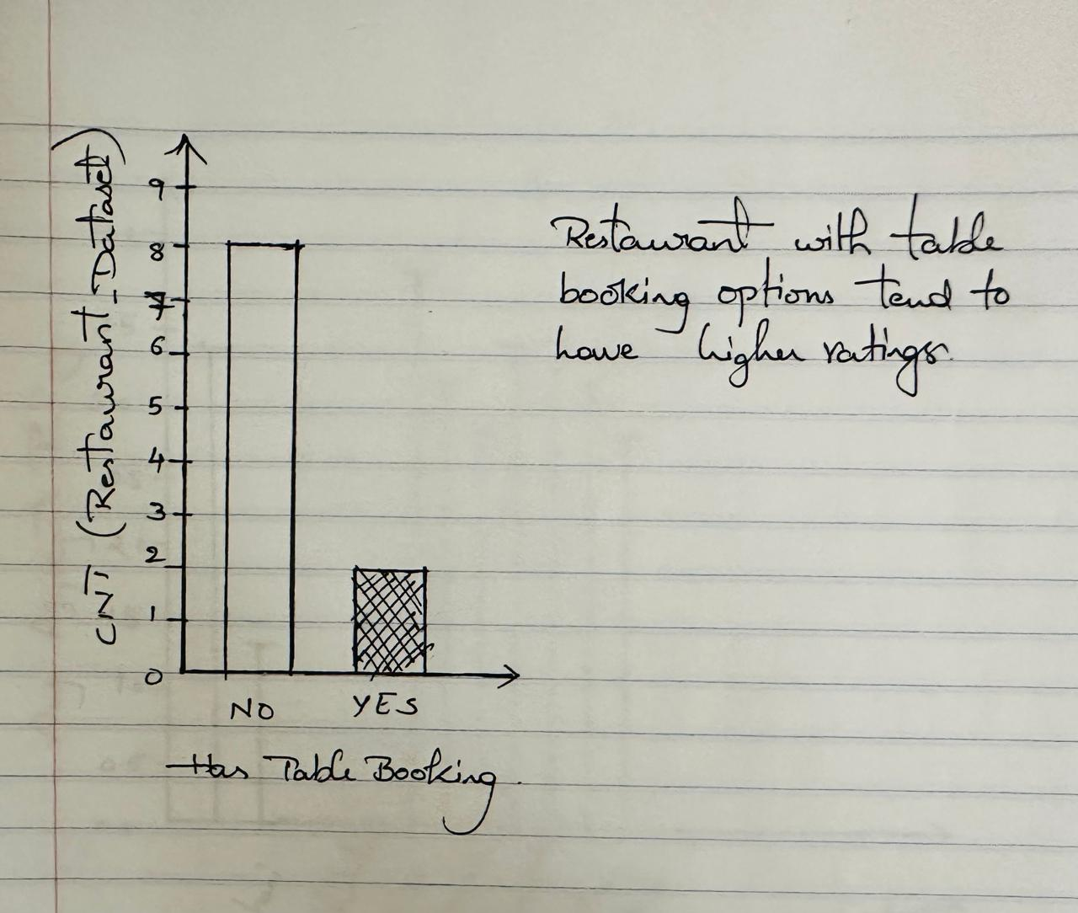

Actual Sketch:

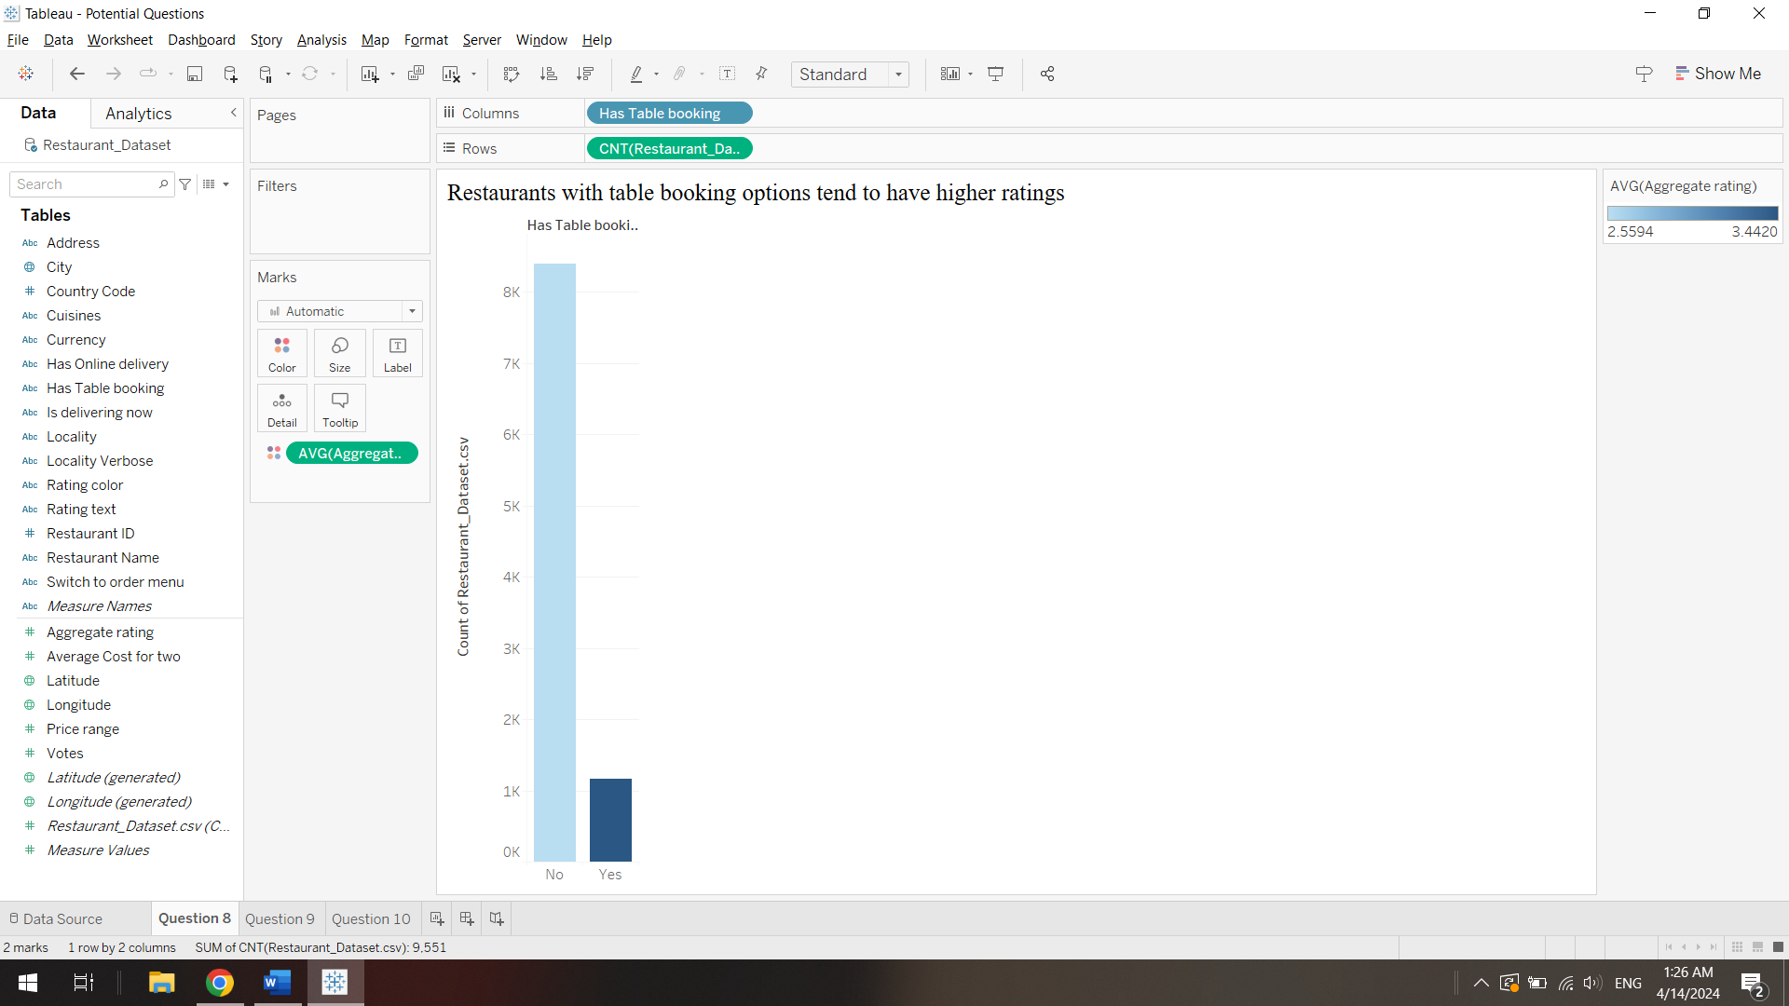

**9.** **How does online food ordering vary across different Country pin codes?**

Columns: Has Online Delivery

Rows: Count of Dataset

Pre-Attentive Attributes:

* Position: Use position to arrange the data effectively. For example, you can arrange pin codes along the X-axis in ascending or descending order based on the count of datasets. This helps viewers easily identify which pin codes have the highest and lowest online food ordering activity.
* Size: Utilize size to represent the count of datasets. Larger sizes indicate a higher count, while smaller sizes indicate a lower count. This allows viewers to quickly discern which pin codes have more online food ordering activity.

Explanation: The graph visually represents the distribution of online food ordering across different country pin codes. Each bar represents a pin code, with the color indicating whether online delivery is available or not. The size of each bar corresponds to the count of datasets, indicating the level of online food ordering activity in that pin code. Viewers can quickly identify which pin codes have the most online food ordering activity and whether online delivery is widely available across all pin codes or limited to certain areas.

Rough Sketch:

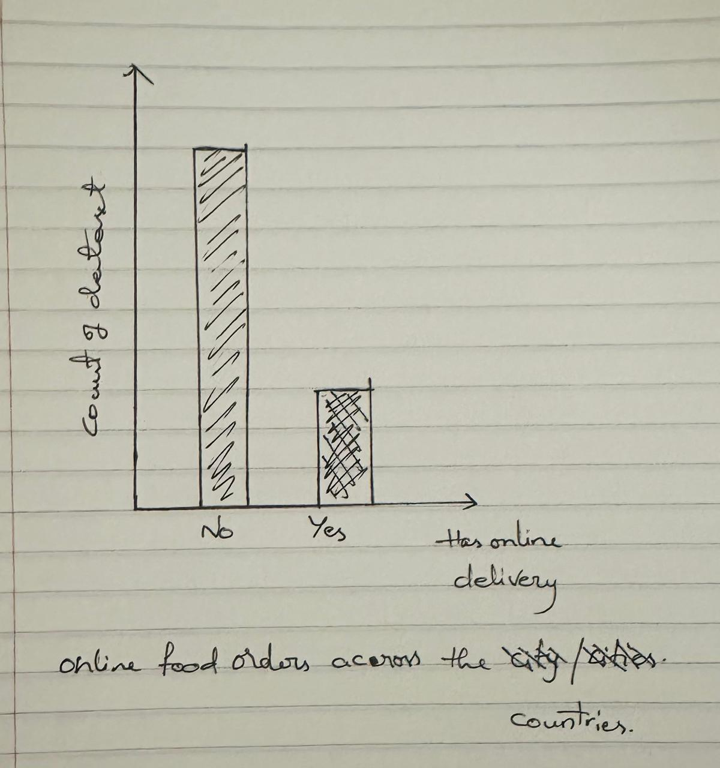

Actual Sketch:

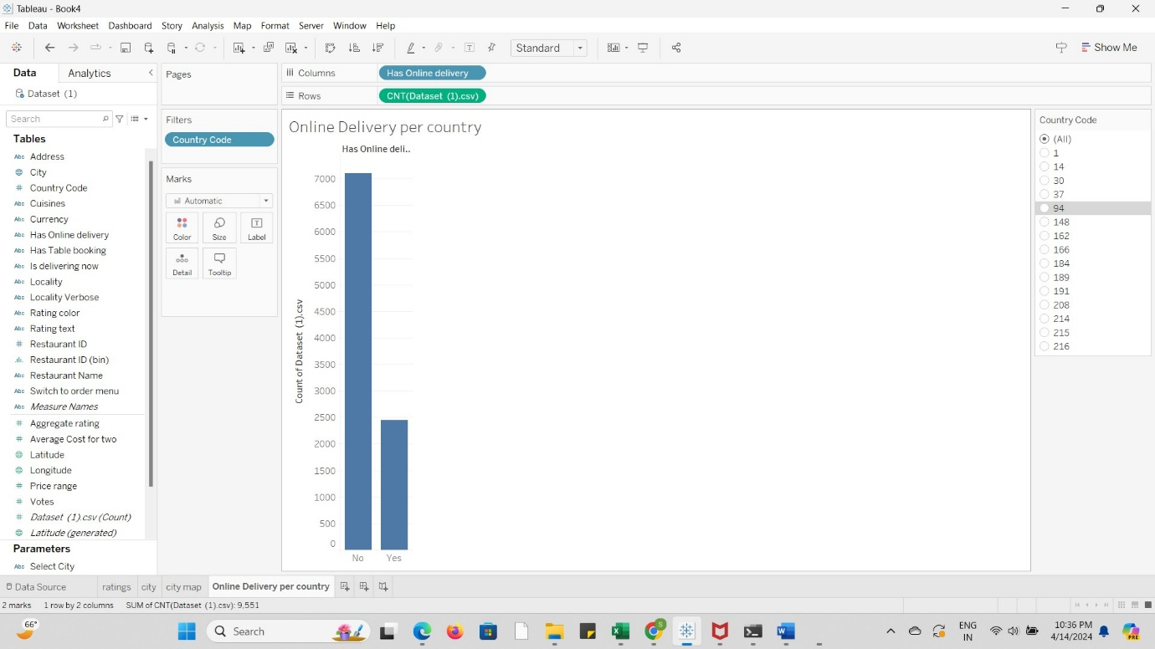

**10. How does the frequency of table bookings correlate with the overall count of restaurants?**

Columns: Has Online Delivery (Boolean)

Rows: Count of Dataset

Pre-Attentive Attributes:

* Length/Height: Make the bar lengths or heights noticeably different for each category to highlight the contrast between restaurants with and without online delivery.
* Position: Ensure clear spatial separation between the bars representing the two categories, placing them side by side or in separate sections of the graph.

Explanation: This graph illustrates the distribution of restaurants based on whether they offer online delivery services. The x-axis represents two categories: "Has Online Delivery" and "Does Not Have Online Delivery," indicating whether a restaurant provides online delivery (Boolean: True) or not (Boolean: False). The y-axis displays the count of restaurants falling into each category, providing an overview of the dataset's composition in terms of online delivery services. Interpreting the graph allows us to understand the proportion of restaurants that offer online delivery compared to those that do not. This insight can inform decisions related to marketing strategies, customer convenience, and operational considerations within the restaurant industry.

Rough Sketch:

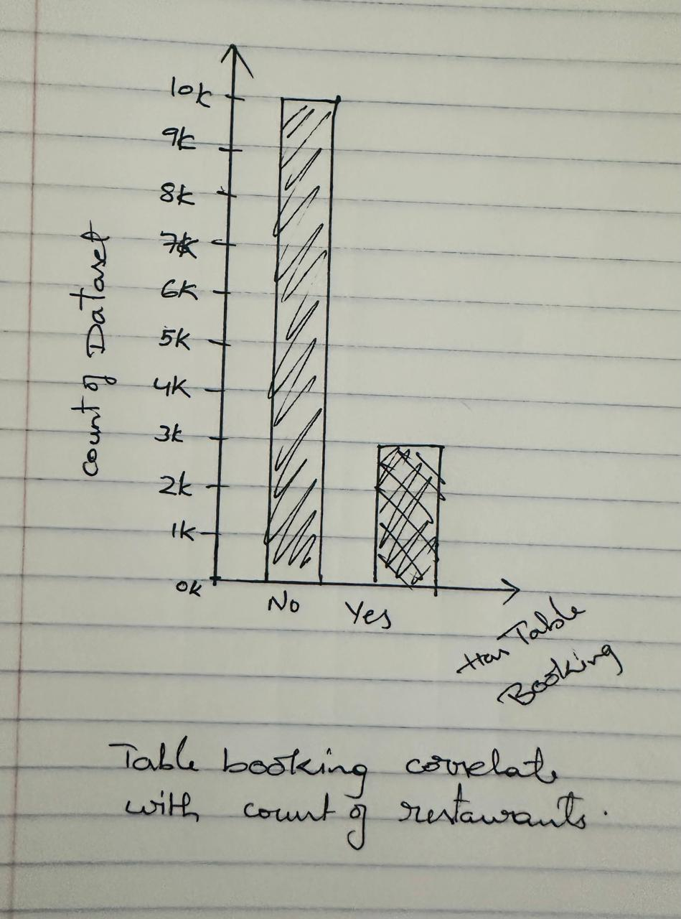

Actual Sketch:

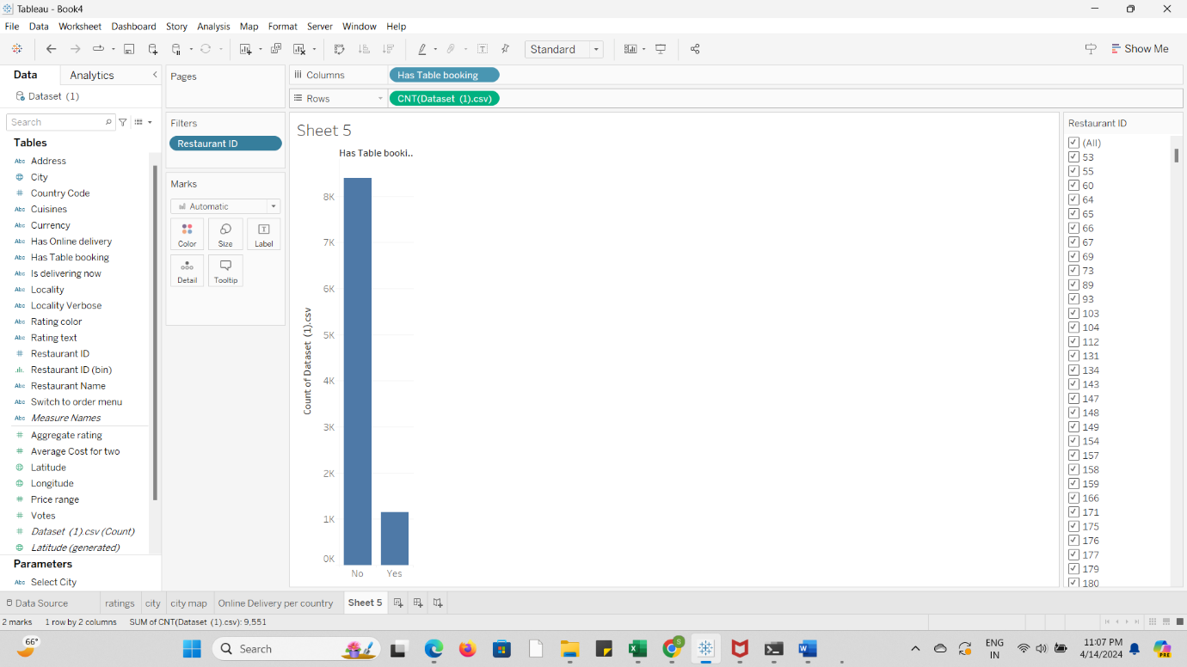

**Section 5: Dashboard Interactivity**

1. **Which restaurants have the highest number of votes and how does it correlate with their ratings?**
2. Enables consumers to choose individual eateries or a collection of eateries according to their names. This might be helpful for comparing or analyzing intricate trends throughout successful eateries.
3. Loaded dynamically from the 'City' attribute, including all unique city names present in the dataset.
4. The Votes Threshold Slider, Rating Slider, City Filter, and Restaurant Filter will all be directly used in this plot. Every restaurant will be displayed as a point plotted against the rating (Y-axis) and number of votes (X-axis). Each point might have a different size or color to represent different data dimensions (like average cost).

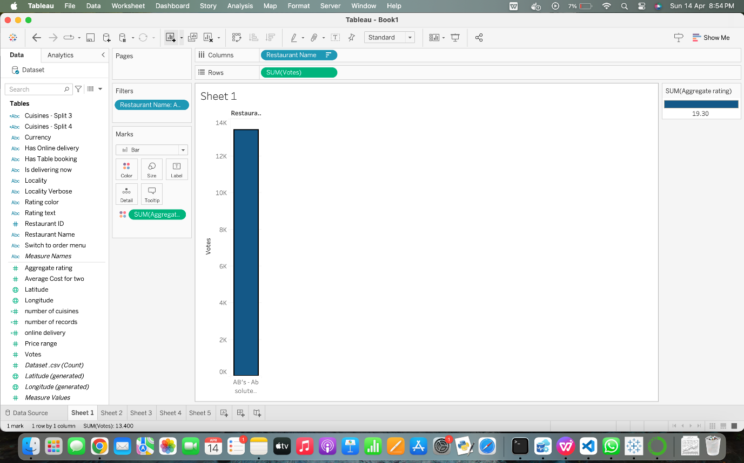

**2. How does the average cost for two vary by city and cuisine?**

1. Gives consumers the option to view the depiction of one or more cities. This might assist users in narrowing their attention or comparing a few chosen cities.
2. Box Plot or Bar Chart showing average cost for two. Every distinct city found in the data will be included in the range. The 'City' property in the data will be dynamically loaded to load this control.
3. Usually ranges from the 'Average Cost for two' attribute's minimum to highest value. If the dashboard is configured to update this control based on other filters, this range, which is dynamically loaded, might change depending on the city and cuisine filters.

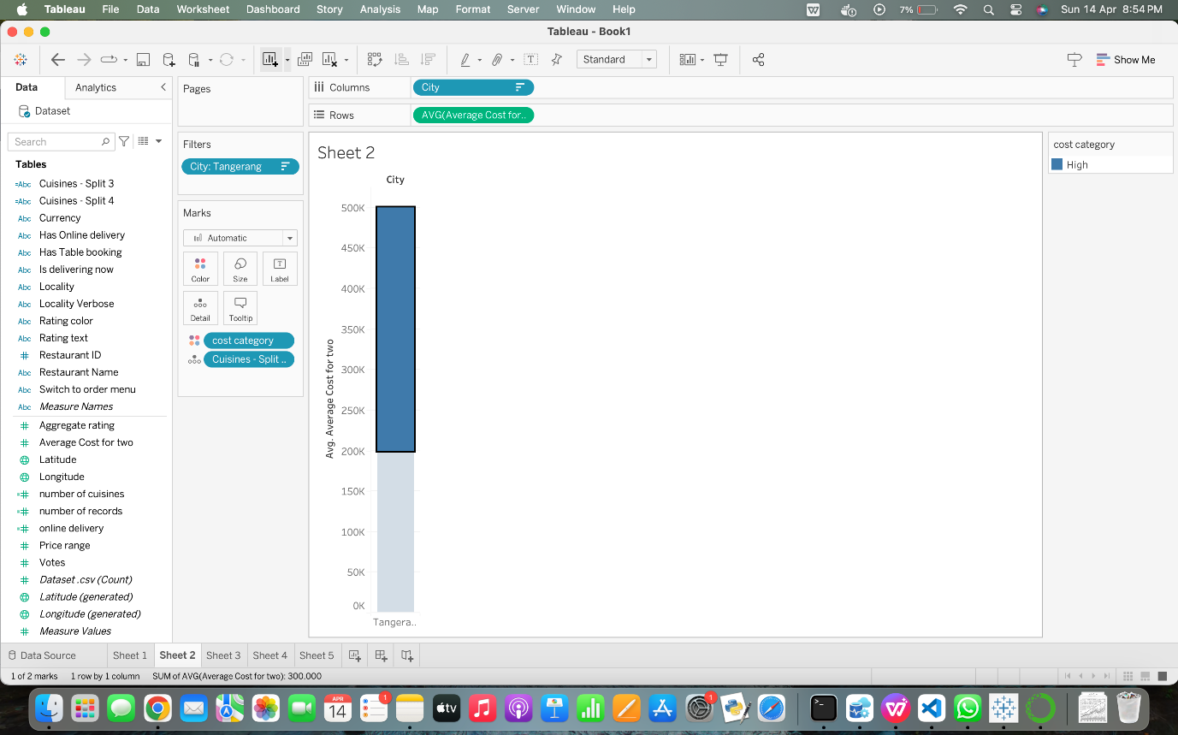**3. How do ratings correlate with the price range of restaurants?**

1. Let’s users choose which cities to view. When users wish to compare a few cities with each other or concentrate on certain regions, this is helpful.
2. This control should include all unique cities present in the dataset, dynamically loaded from the 'City' attribute. Loaded dynamically from the 'Country' attribute, including all countries represented in the dataset.
3. The City Filter and Online Delivery Filter will be the main filters used in this bar chart. Every bar symbolizes a city, and the height of the bar shows how many eateries provide online delivery options. The 'Yes' and 'No' values for online delivery might be represented by distinct bars or color coding in this chart to provide a more comparable view within each city.

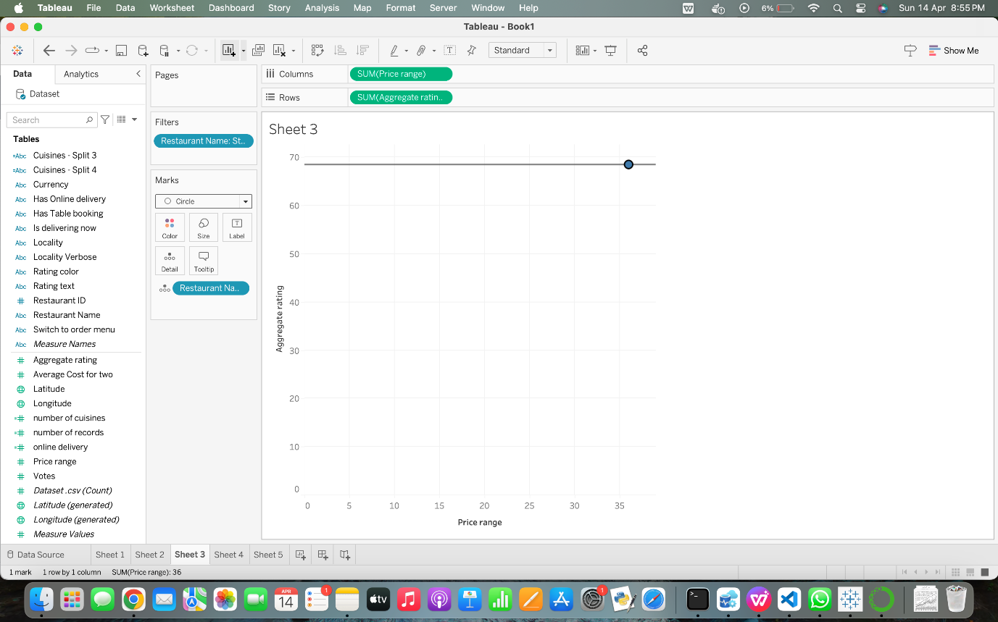

**4. Which cities have the highest number of restaurants offering online delivery?**

1. Allows users to compare the number of restaurants with and without this service within each city, or to limit the view to just display those restaurants that provide online delivery.
2. A more interesting and educational investigation of the data is made possible by users' ability to interactively alter what they see and how they perceive it.
3. The online delivery toggle and the city filter will be the main tools used in this display. Every city will be shown as a bar, with the height of the bar signifying the quantity of eateries that provide online delivery. Bars can optionally be divided or colored differently to show if online delivery services are available or not.

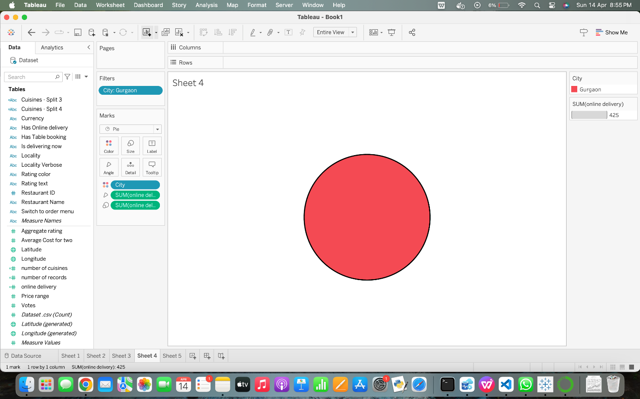

**5. How does the number of available cuisines affect restaurant popularity in terms of votes?**

1. Enables users to examine the link between restaurant popularity and culinary variety within selected geographic areas by selecting individual cities or all cities.
2. A dynamic approach to investigate theories or identify trends is provided by users' ability to dynamically alter parameters like as the quantity of cuisines or voting thresholds, allowing them to observe the instantaneous impact of these elements on popularity.
3. The main visual aid for examining the relationship between a restaurant's popularity as measured by votes and the number of cuisines it serves is this plot. Plotted with the number of cuisines on the X-axis and the number of votes on the Y-axis, each point in the scatter plot represents a restaurant. For further insights, the points might be color-coded according to a city or another category.

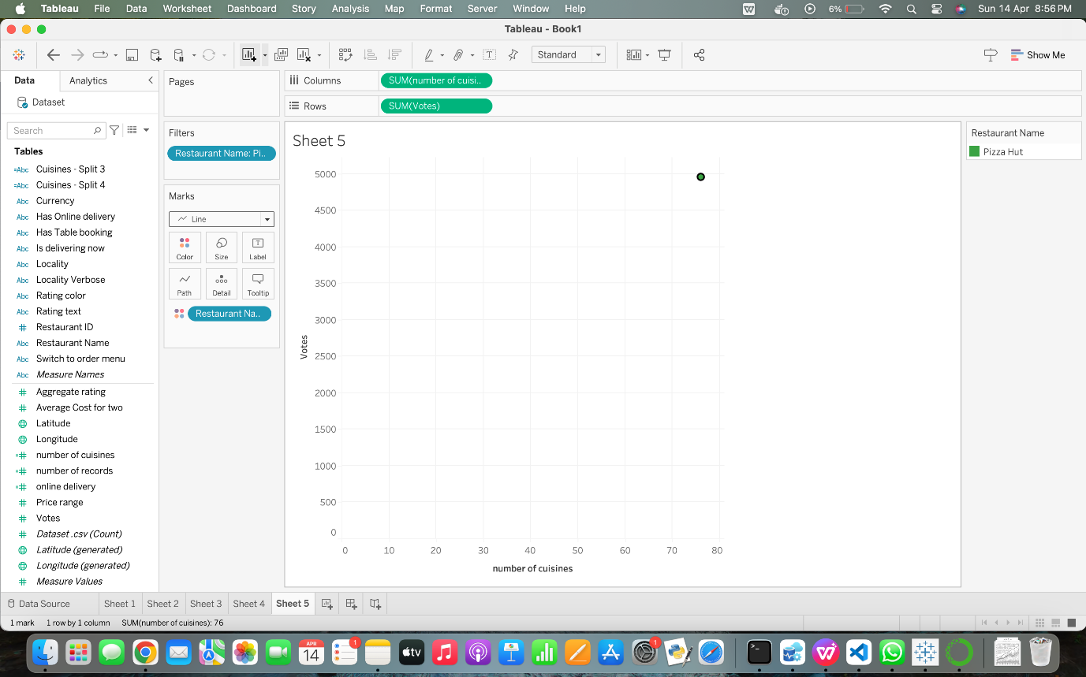

**6. How to find total number of ratings for every restaurant?**

1. The drop-down menu for city selection: This control lets the individual pick a particular city from the list of alternatives.
2. Bar graph displaying restaurant ratings in the chosen city: The dropdown menu's selected city's restaurant ratings are shown in this graphic. Every bar is a restaurant, while the standing bar's height reflects the restaurant's rating.
3. Using a drop-down menu, choose the city: The set of cities included in the dataset is consistent with the value range. The dropdown menu's values are dynamically loaded from the dataset's "City" property. The visitor may constantly change the chart with bars to see the dining ratings in the city they have selected through the menu selection dropdown. With this interactive control, users may explore and evaluate the data according to their hobbies and tastes, which improves the dashboard's usefulness.

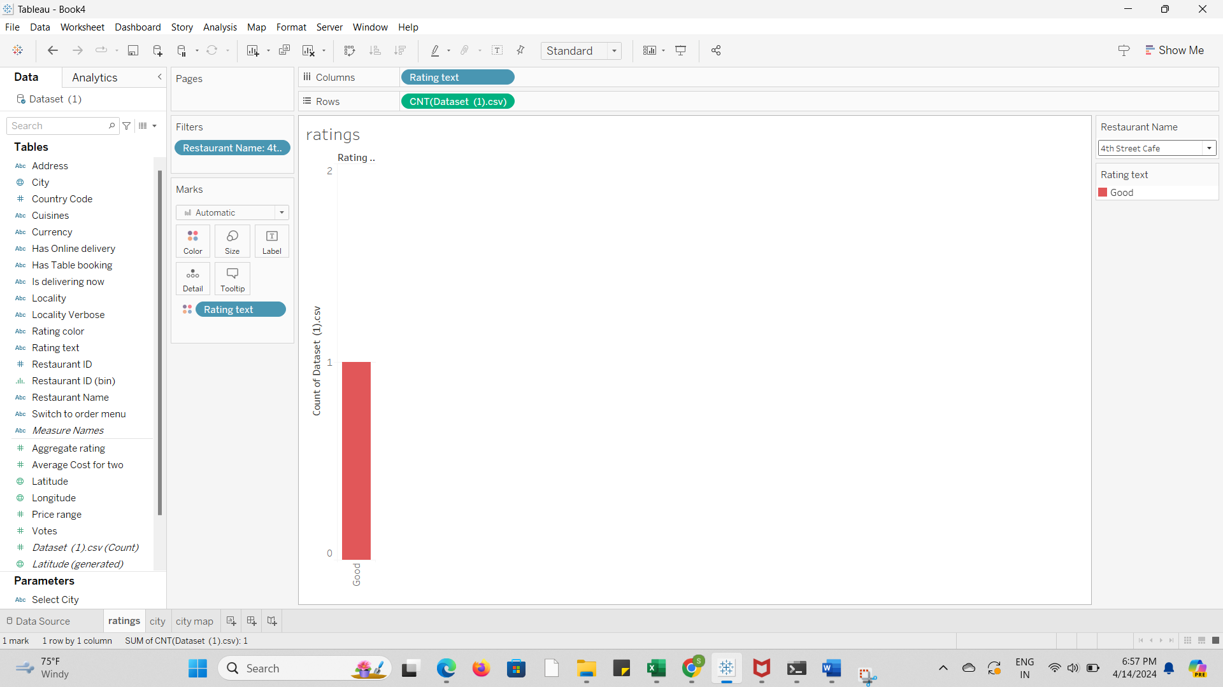

**7. How to find total number of cuisines based on city?**

1. Wild card Match: Entering the city's name in the text input field will allow the user to filter the data.
2. A table or bar chart displaying the variety of cuisines available in the chosen city: The number of cuisines offered in the city that the text input specifies is plotted here. A cuisine is represented by each bar or row, and a height or count indicates how many restaurants in the chosen city provide that particular food.
3. Input text to enter the name of the city: The value range is in line with the dataset's collection of city names. There isn't a set value range, though, because the user is allowed to input any city name. Using data provided by the consumer, the input is constantly loaded.

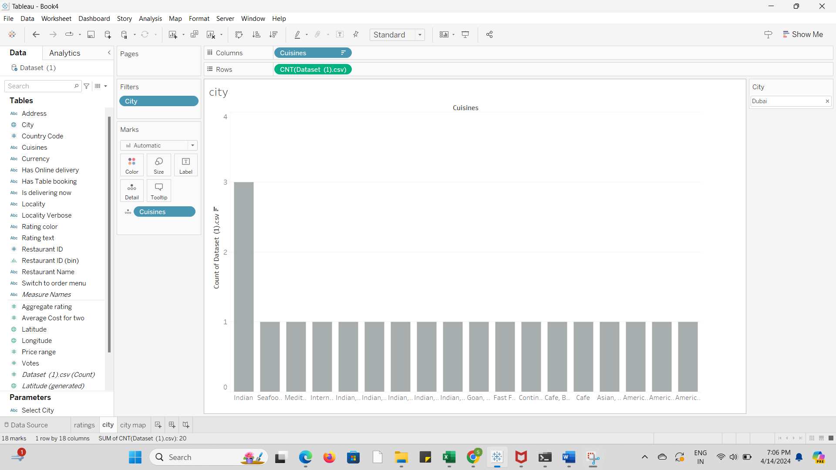

**8.** **Do restaurants with table booking options tend to have higher ratings?**

1. Interactive Control: Drop-down menu for city selection.
2. Connected Plots: Bar chart displaying average ratings for restaurants with and without table booking options.
3. Value Range: The drop-down menu allows users to select a city from a list of options. The list of cities is loaded from the "City" attribute in the dataset.

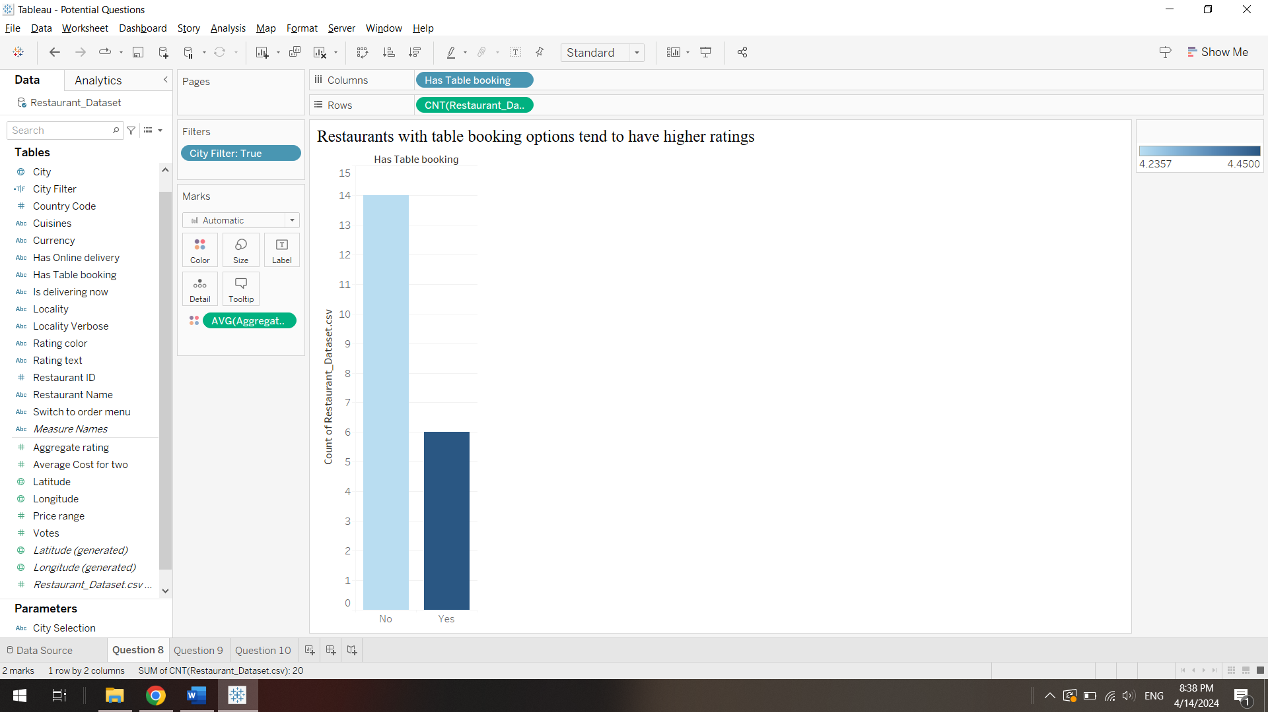

**9.** **How does online food ordering vary across different country pin codes?**

1. Interactive Control: Drop-down menu for country selection code.
2. Connected Plots: Type of chart displaying online bookings for country.
3. Value Range: Users can select a country code from the drop-down menu. The list of countries codes like 208 in this example is loaded from the Pin codes attribute in the dataset.

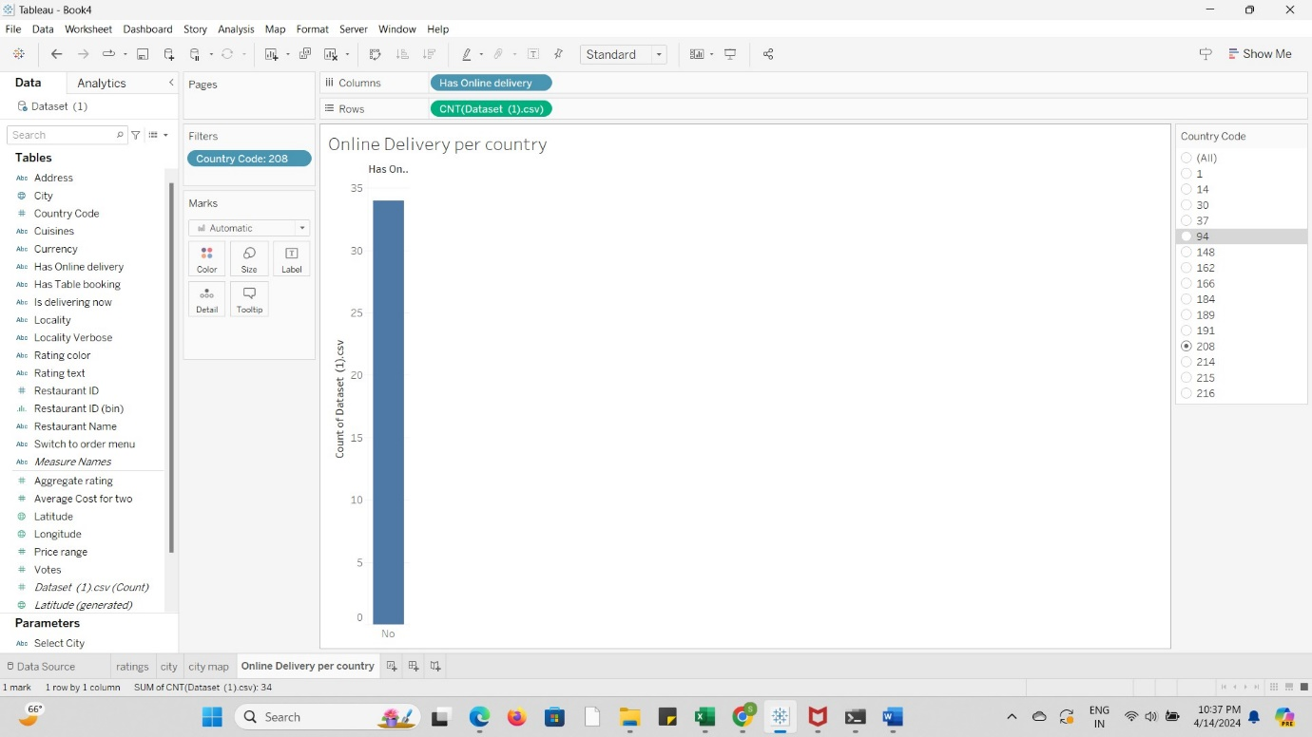

**10. How does the frequency of table bookings correlate with the overall count of restaurants?**

1. Interactive Control: Enable dynamic filtering by restaurant ID to explore variations in booking frequency across different segments.
2. Connected Plots: Alongside the main bar graph, include linked bar charts or line graphs to visualize additional dimensions, such as the relationship between booking frequency and average revenue per booking or the trend of booking frequency over time.
3. Value Range: Ensure the axes cover appropriate ranges of values to accurately represent the data without distortion, with tick marks at regular intervals for clarity, facilitating accurate interpretation and comparison of data points.
4. Here, 5 IDs have been selected & NO filter is the one with no table booking for a restaurant.

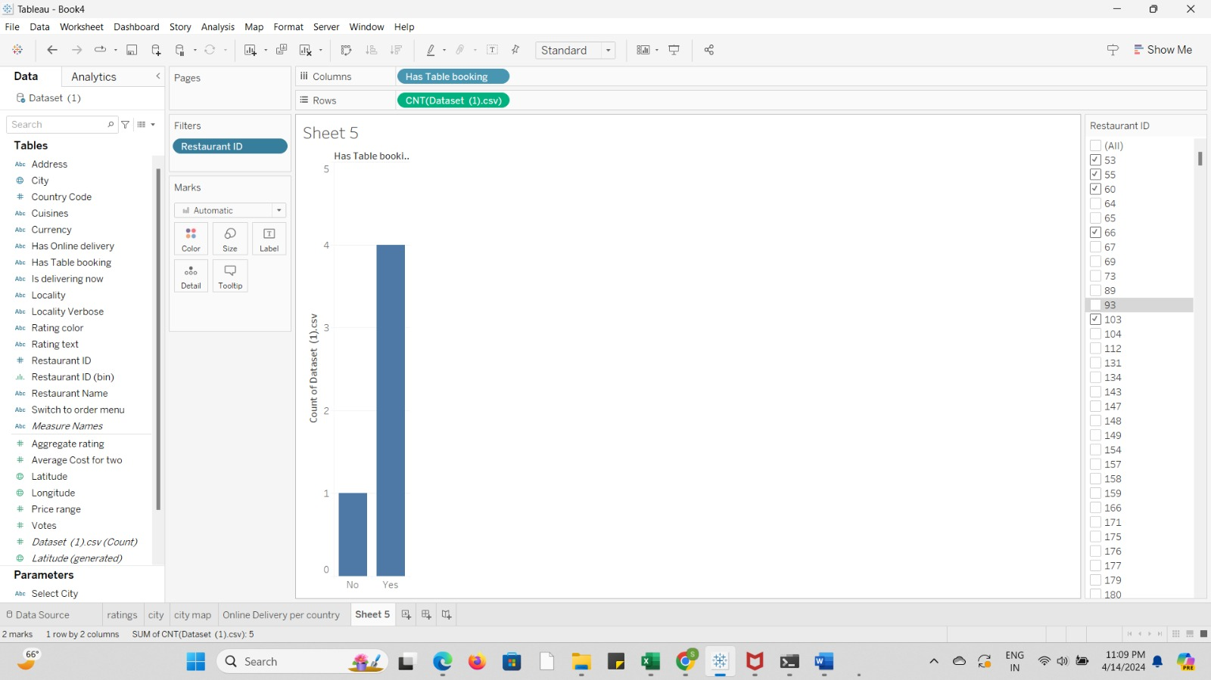

**Section 6: References**

Mural Link: [**https://app.mural.co/t/sushank5030/m/sushank5030/1712263790900/fc5f85f8e428ec23711fdae39d82782efc901bf5?sender=ueb02cce70d4e3ee0d5484586**](https://app.mural.co/t/sushank5030/m/sushank5030/1712263790900/fc5f85f8e428ec23711fdae39d82782efc901bf5?sender=ueb02cce70d4e3ee0d5484586)